Assistant Appraisal Instrument

To be used alongside:
DERS

The Assistant Appraisal Instrument (AAI) is designed to enable targeted, constructive, summative assessment of developmental practice. The AAI consists of 36 items linked to various indicators, which are clustered around four domains: Preparation, Invitation, and Protection.
The instrument focuses on Assistant moves that support the interaction between the Lead Guide, the child and the environment on the path to classroom normalization. In support of the Lead Guide the Assistant offers protection of lessons, flexibility in function, and awareness of lessons given and received. The Assistant supports the child to engage in constructive activity, and once the child is engaged, protects that engagement in ways that both support the child’s attention and concentration and model respectful social interaction. Care of the environment is a critical role and requires constant attention and management.
AAI’s emphasis on Assistant behavior aims to provide evaluators a rigorous appraisal based on highly specific, detailed analysis of practice.
How to Use the Tool
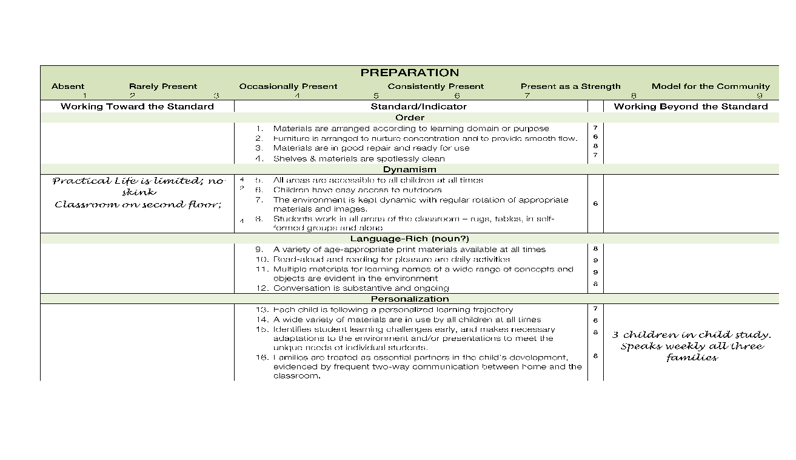
To be most effective, the AAI should be used as part of a constellation of observational, self-report, and reflective data. Data sources include: Notes collected through classroom observations and the Developmental Environmental Rating Scale, self-assessment and reflection and conversations with the Assistant.
Using these sources, the evaluator scores each of the items based on a 1-9 scale. Score of 6 and above should be entered to the right of the item; and scores below 6 to the left. Items are totaled to produce (1) and Indicator Score and (2) a Domain Score. Indicator Scores enable the evaluator and the Assistant to identify specific areas of strength and growth, and Domain Scores allow a more holistic view of the Assistant’s practice. In the sample (right), the Assistant is working beyond the standard in all but one Indicator, and her Domain Score is 107 out of a possible 144.
A qualitative appraisal, along with recommendations for future attention and refinement, is composed by the evaluator based on insights provided by the indicator and domain scores.

PREPARATION

Absent Rarely Present Occasionally Present Consistently Present Present as a Strength Model for the Community
1 2 3 4 5 6 7 8 9
Working Toward the Standard |  | Standard/Indicator |  | Working Beyond the Standard
Order
- Materials are returned to original arrangement according to learning domain or purpose.
- Furniture is returned to original arrangement to nurture concentration and to provide smooth flow.
- Notify Lead Guide if materials are not in good repair and ready for use.
- Shelves & materials are clean and organized.
Dynamism
- All areas are accessible to all children at all times.
- The environment is kept dynamic with support of regular rotation of appropriate materials and images.
- Students work in all areas of the classroom – rugs, tables, in self-formed groups and alone.
Language-Richness
- A variety of age-appropriate print material is kept complete, in good repair.
- Reading to individuals and small groups are daily activities.
- Desired communication habits are modeled in each interaction (use of precise vocabulary etc.)
- Conversations are two-way.
Awareness
12. Attends to restocking of shelves without prompt.
13. Independently manages freshness of consumable materials.
14. Seamlessly facilitates daily routines and needs of the classroom.
Total Indicator Scores Total Domain Score ____/126
Order _____/36 Dynamism_____/27 Language-Rich_____/36 Awareness_____/27

INVITATION

Absent Rarely Present Occasionally Present Consistently Present Present as a Strength Model for the Community
1 2 3 4 5 6 7 8 9
Working Toward the Standard |  | Standard/Indicator |  | Working Beyond the Standard
Repertoire
- Uses appropriate language associated with Montessori materials.
- Redirects children to materials presented by Guide.
Clarity & Economy
- Provides clear direction/instructions.
- Selects words to use so that the child can both understand and build vocabulary.
Wonder
- Communicates genuine curiosity and excitement about each activity.
- Shares the child’s joy of discovery.
- Fully engages in every interaction, with children, peers, families, and visitors, offering their undivided attention.
- Supports continued perseverance following error.
Precision
- Intentional use of gesture and movement.
- Models grace & courtesy in all interactions (crossing room to talk to individuals, carries chairs properly etc.)
Flexibility
- Responds to the variety of student needs throughout the day.
- Willingness to adjust to the needs of the classroom/school.

Total Indicator Scores Total Domain Score ____/108
Repertoire _____/18 Clarity & Economy_____/18 Wonder_____/36 Precision_____/18 Flexibility_____/18

PROTECTION

Absent Rarely Present Occasionally Present Consistently Present Present as a Strength Model for the Community
1 2 3 4 5 6 7 8 9
Working Toward the Standard |  | Standard/Indicator |  | Working Beyond the Standard
Respect for Engagement
- Protects guide’s lessons at all times and attends to the needs of students allowing the guide to be uninterrupted during presentations.
- When engaging with a child, scans room while remaining focused on the work of that individual.
- Uses a soft, conversational voice most of the time, using a firm tone only when necessary.
- Models respect for the child’s work and space by asking permission before touching work.
Appropriate Assistance
- Redirects children to solve problems independently.
- Waits to offer assistance until independent problem-solving strategies have failed.
- Remains alert to children who are experiencing challenges and ready to support if needed.
Consistency & Predictability
- Moves around the classroom with obvious purpose.
- Is nonreactive when managing unexpected difficult situations.
- Sets and maintains consistent limits.
Total Indicator Scores Total Domain Score ____/90
Respect for Engagement _____/36 Appropriate Assistance_____/27 Consistency & Predictability_____/27

Assistant Appraisal Instrument Summary

Domain | Consistently Present | Personal Totals
Preparation | 84-126
Invitation | 72-108
Protection | 60-90

Areas of Strength
List all areas with a score of 6 and above and describe specific instances of how this strength is evidenced in the Assistant’s practice.

Areas of Growth
List all areas with a score of 4 and below and make specific recommendations for how the Assistant may address these areas.

Goal

