IMPLEMENTING THE MEFS APP: ORGANIZING YOUR ACTION PLAN

Like all successful projects, it is important to thoughtfully develop and schedule your implementation. An assessment plan will help you work through many moving parts – from timing, to availability of staff and resources, to planning for the unexpected, to the frequency/amount of data you should collect in order to reach your goal. It may be helpful to organize your thoughts on a calendar, mind map, or timeline. Below we have some different plans that may be helpful for you as you work through your own implementation.

IMPLEMENTING THE MEFS APP: EXAMPLES

Example 1: Using the MEFS App in Admissions

The MEFS App can be used successfully as an admissions tool. In most cases, schools using the MEFS for admissions collect data one time annually, at the beginning of the school year. Here is an example action plan:

Our MEFS Purpose: |  |  | Admissions
We will be assessing | 1 | Times per year; in |  | Late August/early September
Assessments Will Take Place (Location): |  |  | All will take place in room 3A
Our Lead Examiner (MEFS Supervisor) is: |  |  | Megan Moore
Things to Remember… |  |  | Administer MEFS between ‘test A’ and ‘test C’

Example 2: Using the MEFS App to Measure Curriculum/Intervention Efficacy

The MEFS App can be used to measure the efficacy of your curriculum or intervention. Here, you are likely looking for growth over time. We recommend collecting MEFS App data 2-3 times per year (i.e. Fall-Winter-Spring or Fall-Spring) depending on your capacity. Here is an example action plan:

Our MEFS Purpose: |  |  | Second Step Curriculum Efficacy
We will be assessing | 2 | Times per year; in |  | Fall and Spring
Assessments Will Take Place (Location): |  |  | TBD; likely homeroom during breaks
Our Lead Examiner (MEFS Supervisor) is: |  |  | Dan Johnson
Things to Remember… |  |  | In Fall, use Game Form A.  In Spring, use Game Form B.

Example 3: Using the MEFS App for Student Progress Monitoring

The MEFS App can be used to track the development of EF in students. We recommend assessing students 2-3 times per year (i.e. Fall-Winter-Spring or Fall-Spring) depending on your capacity. Here is an example action plan:

Our MEFS Purpose: |  |  | Monitoring PK – 1st Gr. EF Progress
We will be assessing | 3 | Times per year; in |  | Fall, Winter, and Spring
Assessments Will Take Place (Location): |  |  | 4K assessments will take place in room 2A, 5K in room 2B, and 1st Grade in the Music Room
Our Lead Examiner (MEFS Supervisor) is: |  |  | Susan Smith
Things to Remember… |  |  | Susan will be out of office Dec 8 – 16

Below is an example of a TIMELINE for Example 3
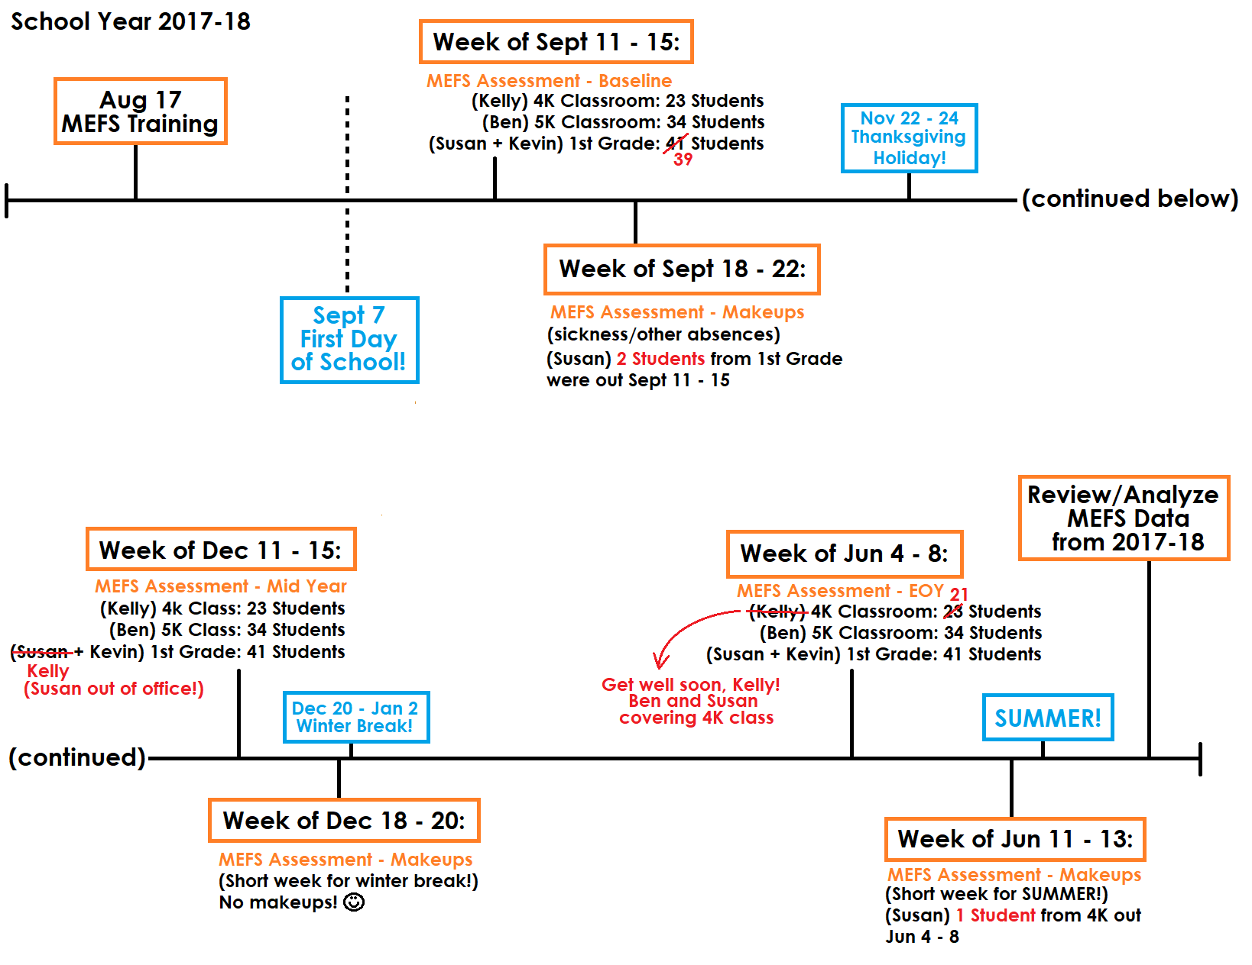

YOUR MEFS IMPLEMENTATION PLAN

Use this space to create your own action plan.

Our MEFS Purpose:
We will be assessing |  | Times per year; in
Assessments Will Take Place (Location):
Our Lead Examiner (MEFS Supervisor) is:
Things to Remember…

Use this space for your calendar, mind map, timeline, etc.:

